Course: Data Structures (CSE CS203A)
Assignment V: Tree

Due date: 2025.12.30 23:59:59

Important Notice – Use of AI Tools
In this assignment, you must use at least one AI assistant (e.g. ChatGPT, Gemini, Claude, Grok, M365 Copilot) as a learning tool to help you:
- review definitions,
- compare tree variants, and
- organize your report.
You are not allowed to let the AI directly produce your final diagrams or final report content without your own understanding and rewriting.
You must log all AI prompts and services used (see “AI Usage Log” section below).

Goal of This Assignment
In the lectures, we introduced the concept of the tree as a data structure, starting from the general tree and then moving to more specialized forms.
In this assignment, you will:
- Understand and clearly define:
  - General tree
  - Binary tree
  - Complete binary tree
  - Binary search tree (BST)
  - AVL tree
  - Red-Black tree
  - Max heap
  - Min heap
- Build a hierarchy and transformation path from the general tree to these variants, and explain how each variant adds more structure or constraints.
- Use a fixed list of integers to construct multiple tree variants and visualize them.
- Choose one real-world application for each tree type and explain why that data structure fits the application.
- Practice using AI tools as study companions and keep a simple Q&A log.

Given Data
Use the following 20 integers as the input data for all your tree constructions:
37, 142, 5, 89, 63, 117, 24, 176, 58, 133, 92, 11, 151, 72, 39, 184, 7, 101, 54, 160
You will reuse this same sequence for every tree type (binary tree, complete binary tree, BST, AVL, Red-Black, max heap, min heap).

Deliverables
Please complete your work in the Student Worksheet Companion and upload it to the YZU Portal System.
Your report should include the following parts:
- Definitions (Concept Review)
Provide clear, concise definitions for each of the following:
- General tree
- Binary tree
- Complete binary tree
- Binary search tree (BST)
- AVL tree
- Red-Black tree
- Max heap
- Min heap
You are encouraged to use AI tools to help you understand these concepts, but you must rewrite the definitions in your own words.
- Hierarchy and Transformation of Tree Variants
Based on the definitions above, build a “tree family hierarchy” that shows how these structures are related. For example:
- General tree → Binary tree
- Binary tree → Complete binary tree / Binary search tree
- BST → AVL tree / Red-Black tree
- Binary tree → Max heap / Min heap
Tasks:
- Draw a diagram or flow chart that shows the transformation or specialization path:
general tree → binary tree → complete binary tree → BST → AVL/Red-Black, etc.
- For each arrow (transformation), briefly explain:
  - What new constraint or property is added?
  - e.g., “Binary tree = tree with at most 2 children per node”,
“BST = binary tree with left < root < right”,
“AVL = BST with strict height-balance rule”, etc.
- Tree Construction with the Given Integers
Using the given 20 integers, construct the following tree variants:
- Binary tree
- Complete binary tree
- Binary search tree (BST)
- AVL tree
- Red-Black tree
- Max heap
- Min heap
Important Hint / Restriction:
- For these trees, you must use tree visualization tools (e.g., online visualizers or software) to build and display the tree.
- You may not ask AI tools to directly generate the final tree pictures for you.
- Instead:
  - Use AI only to help you understand algorithms,
  - Then apply those algorithms in a visualizer (or your own implementation).
What to submit for this part:
For each tree type:
- A snapshot (image) of the constructed tree.
- The URL / name of the visualization tool you used.
- A short note on how you inserted the integers (e.g., “insert in the given order as BST”, “build max heap using heapify”, etc.).
- Application Example for Each Tree
For each of the following:
- Binary tree
- Complete binary tree
- Binary search tree (BST)
- AVL tree
- Red-Black tree
- Max heap
- Min heap
Choose one application (real-world or system-level) and explain:
- Application description
  - e.g., priority scheduling, dictionary lookup, memory allocation, database indexing, etc.
- Why this tree structure fits
  - What property of this data structure makes it suitable?
  - Example:
    - Max heap → good for priority queue because the largest element is always at the root, so extracting max is efficient.
    - Red-Black tree → good for standard library maps/sets because it guarantees O(log n) operations even under many insertions/deletions.
Your explanation should show that you understand the link between the data structure and its use case.
- Report Layout and Organization
You are free to design the layout of your report, but it should:
- Be well-structured (use sections, headings, tables, and diagrams).
- Have a clear flow from:
  - definitions →
  - hierarchy/transformation →
  - constructed trees →
  - applications →
  - AI usage log.
- Be easy for another student to read and learn from.
Feel free to use AI to suggest a good outline, but you must decide and finalize the layout yourself.
- AI Usage Log (Q&A Table)
Every time you use an AI copilot service for this assignment, record:
- Index (1, 2, 3, …)
- Prompt (what you asked)
- Service (e.g., ChatGPT, Gemini, Copilot, …)
Example log table:
Index | Prompt | Service
1 | Assist me to have the definition of general tree, binary tree, complete binary tree, binary search tree, AVL tree, red-black tree, max heap and min heap for self-learning. | ChatGPT
2 | Explain the difference between AVL tree and Red-Black tree in terms of balancing strategy and use cases. | Gemini
… | … | …
Place this table at the end of your report.

Evaluation (100 pts)
A possible breakdown (you can adjust if needed):
- Concept definitions (20 pts)
  - Correctness and clarity of all 8 tree type definitions.
- Hierarchy & transformation explanation (20 pts)
  - Clear diagram / explanation of how each tree variant evolves from the general tree.
  - Correct identification of constraints/invariants.
- Tree constructions & visualizations (25 pts)
  - Correct constructions for each tree type using the given integers.
  - Proper screenshots and tool URLs.
  - Consistent insertion / heap-building strategy descriptions.
- Applications & explanations (20 pts)
  - One application per tree type.
  - Clear explanation linking data structure properties to the application.
- Report organization & AI usage log (15 pts)
  - Logical report structure and readability.
  - AI log completeness (all prompts listed with service names).
  - Thoughtful use of AI as a learning assistant, not as a copy-paste generator.

Course: Data Structures (CSE CS203A)
Assignment V: Tree
Student Worksheet Companion

Due date: 2025.12.30 23:59:59

Academic Integrity and AI Usage Statement
In this assignment, you must use AI tools (such as ChatGPT, Gemini, Claude, Grok, M365 Copilot, etc.) as learning assistants, but you must also take full responsibility for understanding and organizing your own work.

Permitted Use of AI Tools
You may use AI to:
- Review or clarify definitions and concepts.
- Compare different tree data structures.
- Get suggestions for report layout or examples.
- Ask for explanations of algorithms (e.g., BST insertion, AVL rotation, heapify process).
You should read, think about, and rewrite the content in your own words.

Not Permitted
- Do not copy/paste AI-generated content directly as your final answer.
- Do not ask AI to draw the final diagrams or directly produce the final tree screenshots.
- Do not ask AI to complete the whole assignment report for you.

Your Responsibility
- You are responsible for understanding the definitions and algorithms.
- You are responsible for verifying whether AI answers are correct or not.
- You must produce your own original explanations and diagrams.

AI Usage Log
- You must record all AI queries related to this assignment.
- At the end of your report, include an AI Usage Log table with: Index, Prompt, AI service name.
By submitting this assignment, you acknowledge that you have used AI tools only as study aids, and that the final content of this assignment represents your own understanding and work.

Section 1. Definitions of Tree Variants
Task: Write your own definitions for each tree type. You may use AI for learning, but rewrite in your own words.
- General Tree
Definition: 一般樹是一種階層式資料結構，由節點與邊組成，每個節點可以有任意數量的子節點，但整體結構沒有循環，且有一個根節點作為起點。
- Binary Tree
Definition: 二元樹是一種特殊的一般樹，其中每個節點最多只能有兩個子節點，通常稱為左子節點與右子節點。

- Complete Binary Tree
Definition: 完全二元樹是一種二元樹，其所有層級除了最後一層外都必須填滿，而最後一層的節點必須從左到右依序排列。

- Binary Search Tree (BST)
Definition: 二元搜尋樹是一種二元樹，對於每個節點而言，其左子樹中所有節點的值都小於該節點，而右子樹中所有節點的值都大於該節點。

- AVL Tree
Definition: AVL 樹是一種自我平衡的二元搜尋樹，對於任一節點，其左右子樹的高度差不得超過 1，並在插入或刪除後透過旋轉操作維持平衡。

- Red-Black Tree
Definition: 紅黑樹是一種自我平衡的二元搜尋樹，透過節點的顏色（紅或黑）與一組顏色規則，確保樹的高度維持在對數等級。

- Max Heap
Definition: 最大堆積是一種完全二元樹，其中每個父節點的值都大於或等於其子節點，因此最大值一定位於根節點。

- Min Heap
Definition: 最小堆積是一種完全二元樹，其中每個父節點的值都小於或等於其子節點，因此最小值一定位於根節點。

Section 2. Tree Family Hierarchy and Transformations
Task: Show how these structures are related (general → specialized). Use a simple diagram and explanations of what constraints are added at each step.
2.1 Tree Family Diagram
You may draw this by hand and paste a photo, or use drawing tools.
Suggested chain example (you may extend or adjust):
General Tree → Binary Tree → Complete Binary Tree
Binary Tree → Binary Search Tree → AVL / Red-Black
Binary Tree → Max Heap / Min Heap
Your Diagram:
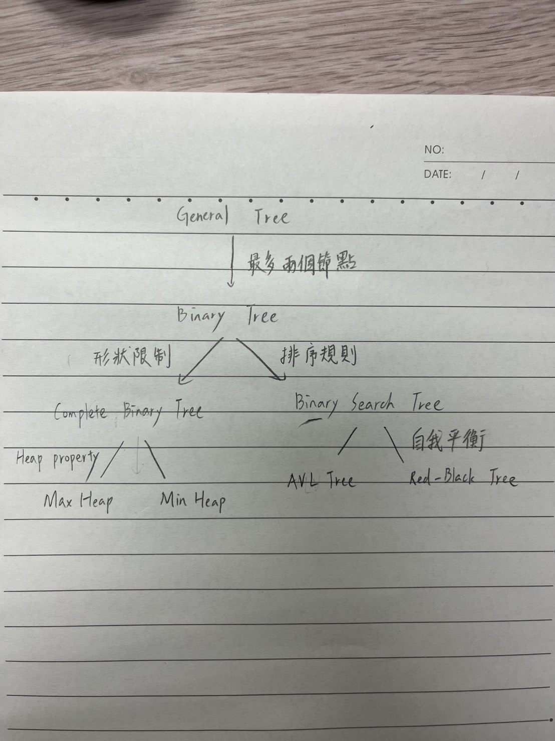

2.2 Explanation of Transformations
Fill in what new property or constraint is added at each step.
From | To | New property / constraint added
General Tree | Binary Tree | 每個節點最多 2 個子節點
Binary Tree | Complete Binary Tree | 節點必須由上而下、由左而右填滿
Binary Tree | Binary Search Tree | 左子樹 < 根 < 右子樹
BST | AVL Tree | 任一節點左右子樹高度差 ≤ 1
BST | Red-Black Tree | 透過紅黑顏色規則限制樹高度
Binary Tree | Max Heap | 父節點 ≥ 子節點，且為完全二元樹
Binary Tree | Min Heap
  父節點 ≤ 子節點，且為完全二元樹

Section 3. Tree Constructions Using Given Integers
Given integers (fixed for all parts):
37, 142, 5, 89, 63, 117, 24, 176, 58, 133, 92, 11, 151, 72, 39, 184, 7, 101, 54, 160
Task: For each tree type below, construct the tree using these integers, take a screenshot of the tree from your chosen tool, record the tool name/URL, and describe the insertion / heap-building procedure.
3.1 Binary Tree
Tool name / URL: https://tree-visualizer.netlify.app/

Construction / insertion description:
依序由上到下、由左到右放節點

Screenshot of Binary Tree (paste below):
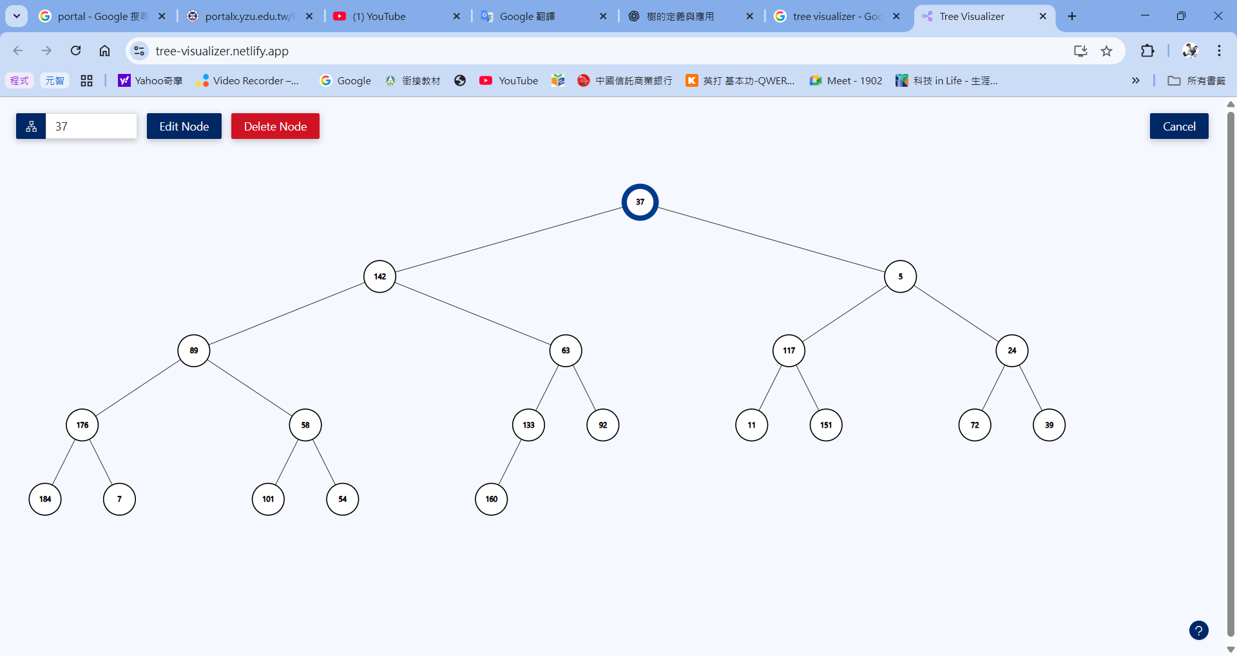

3.2 Complete Binary Tree
Tool name / URL:
https://tree-visualizer.netlify.app/

Construction / insertion description:
完全二元樹是依照給定順序插入節點，並且從上到下、由左至右依序填滿每一層，以確保樹的形狀符合完全二元樹的定義。

Screenshot of Complete Binary Tree (paste below):
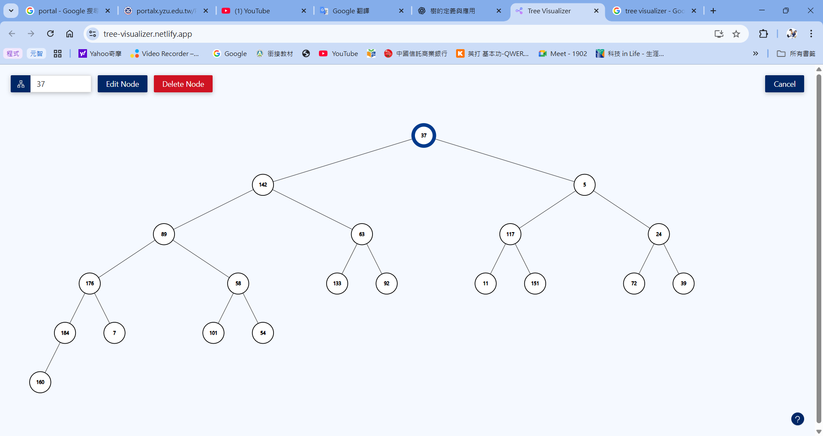

3.3 Binary Search Tree (BST)
Tool name / URL:
https://tree-visualizer.netlify.app/

Insertion rule (e.g., “insert in given order using BST rules”):
依照給定順序逐一插入整數，並遵守二元搜尋樹規則：小於目前節點的值放在左子樹，大於目前節點的值放在右子樹。

Screenshot of BST (paste below):
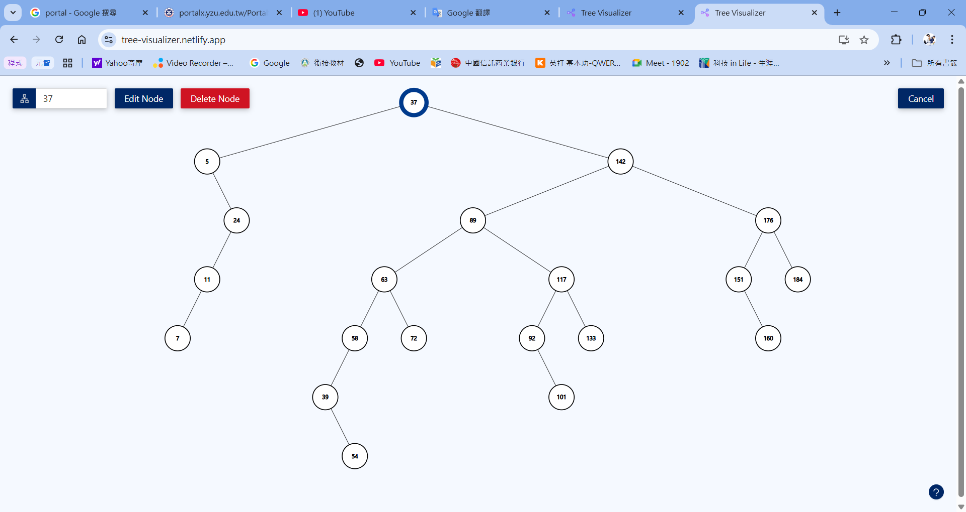

3.4 AVL Tree
Tool name / URL:
https://tree-visualizer.netlify.app/

Insertion & balancing description:
先依照二元搜尋樹的插入規則將整數逐一插入，每次插入後檢查各節點的平衡因子。若出現不平衡，則透過單旋轉或雙旋轉（LL、RR、LR、RL）來維持左右子樹高度差不超過 1。

Screenshot of AVL Tree (paste below):
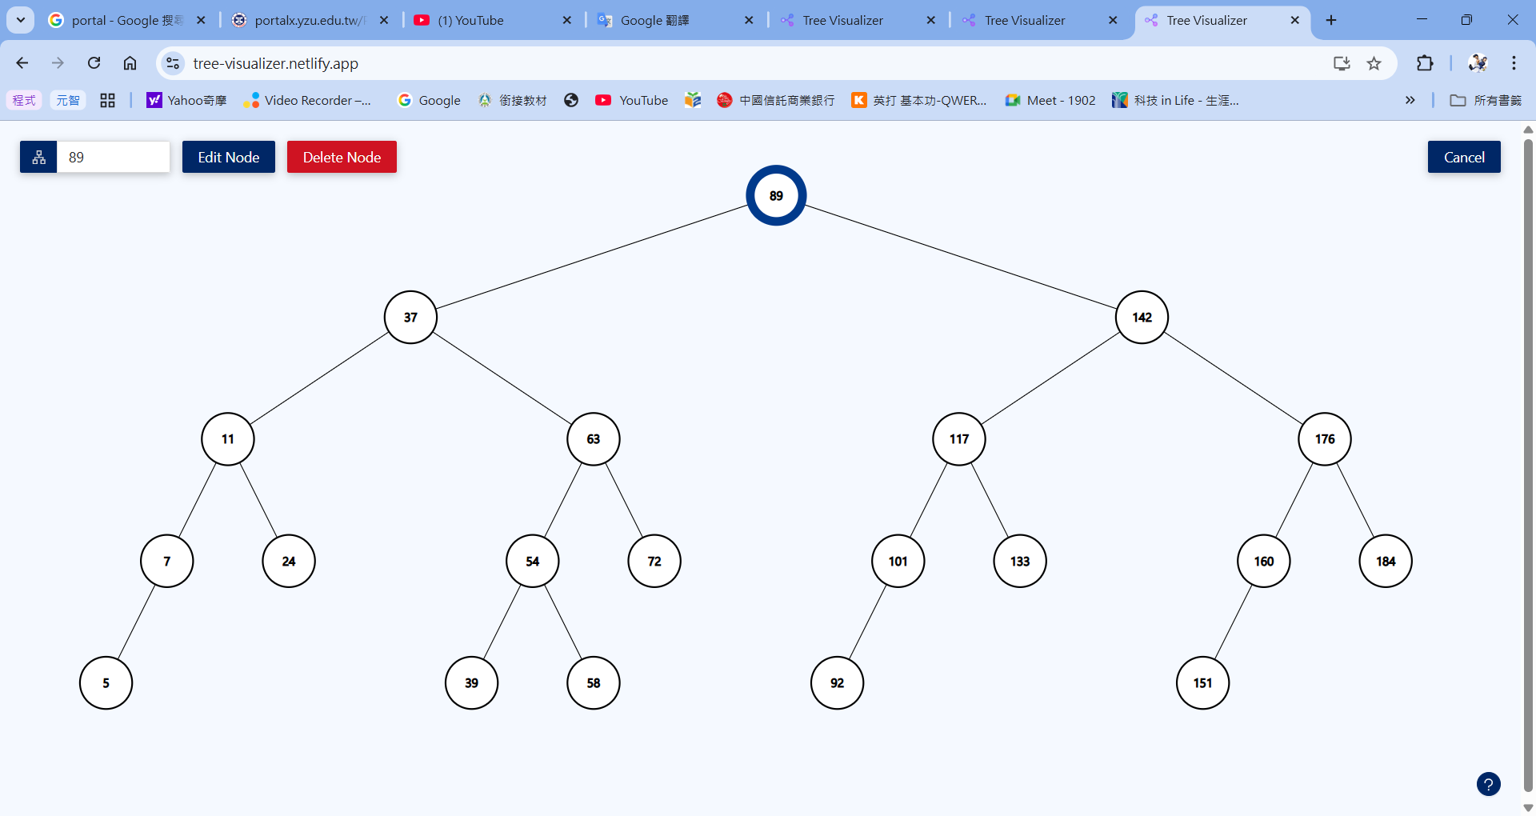

3.5 Red-Black Tree
Tool name / URL:
https://www.cs.usfca.edu/~galles/visualization/RedBlack.html
Insertion & balancing description:
依照二元搜尋樹的插入規則逐一插入整數，新插入的節點一開始設為紅色。若違反紅黑樹性質（例如出現連續紅色節點），則透過重新著色與旋轉操作來恢復紅黑樹的不變條件，使樹維持近似平衡。

Screenshot of Red-Black Tree (paste below):
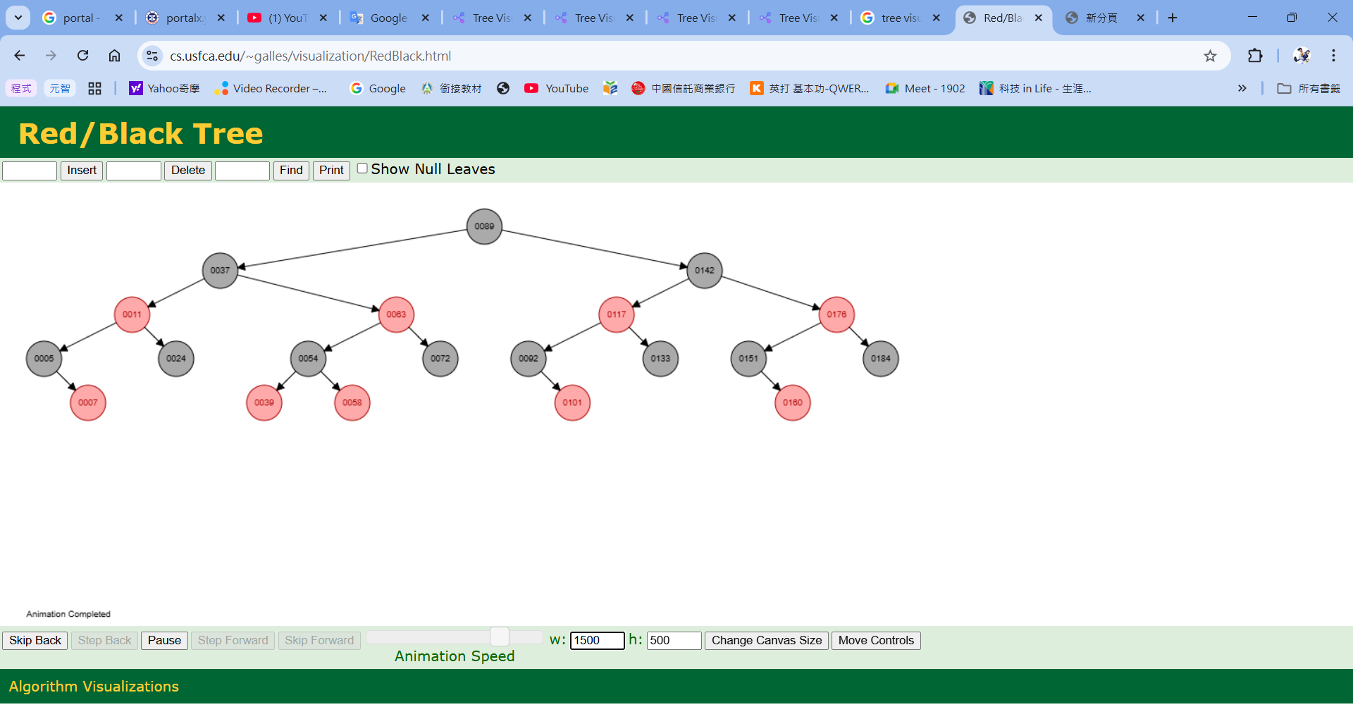

3.6 Max Heap
Tool name / URL:
https://visualgo.net/en/heap
Construction / heap-building description (e.g. heapify, insert-and-sift-up):
依照給定順序將整數插入完全二元樹中，每次插入後透過向上調整（sift-up）來維持 Max Heap 的性質，使父節點的值大於或等於子節點。

Screenshot of Max Heap (paste below):
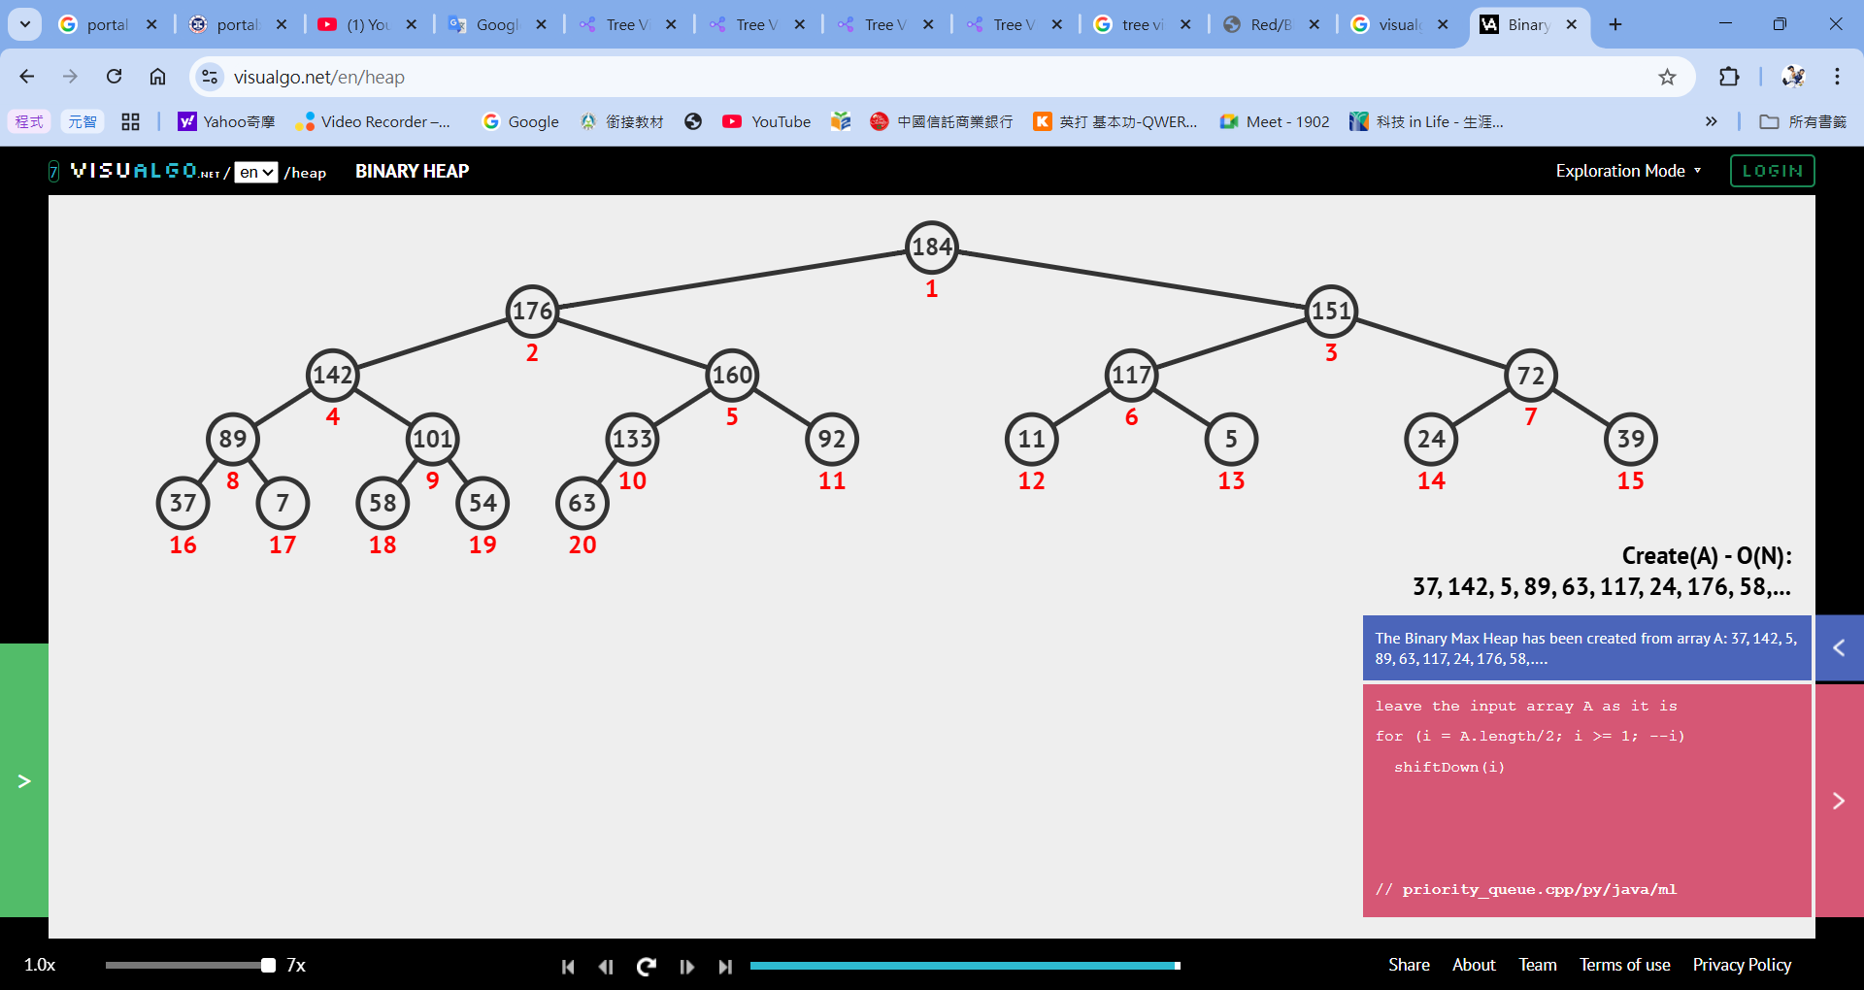

3.7 Min Heap
Tool name / URL:
https://www.cs.usfca.edu/~galles/visualization/Heap.html
Construction / heap-building description:
依照給定順序將整數插入完全二元樹中，每次插入後透過向上調整（sift-up）來維持 Min Heap 的性質，使父節點的值小於或等於子節點。

Screenshot of Min Heap (paste below):
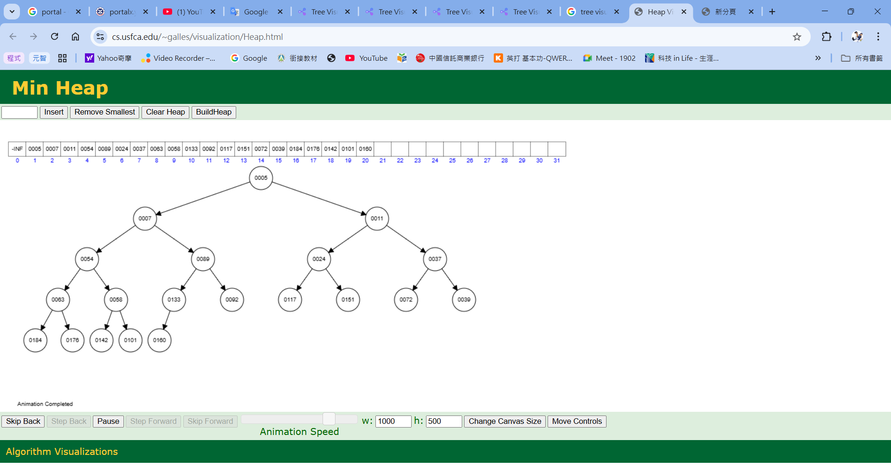

Section 4. Application Examples
Task: For each tree type, choose one application and explain why this tree is suitable.
Tree Type | Application Example (name / context) | Why this tree fits (properties that matter)
Binary Tree | 運算式樹（Expression Tree，用於編譯器或計算機） | 二元樹非常適合表示只有兩個運算元的運算子。內部節點為運算子，葉節點為運算元，透過前序、中序、後序走訪即可對應前綴、中綴與後綴運算式。
Complete Binary Tree | 陣列式樹結構（如堆積、競賽樹） | 完全二元樹的節點排列緊密，可用陣列儲存而不浪費空間，父子節點索引可直接計算，提升記憶體使用效率與存取速度。
Binary Search Tree | 字典／符號表（基本實作） | BST 具有左子樹小於根節點、右子樹大於根節點的排序性質，在平均情況下可於 O(log n) 時間內完成搜尋、插入與刪除，中序走訪可直接得到排序結果。
AVL Tree | 需要大量查詢的資料庫索引（記憶體內） | AVL 樹為嚴格平衡樹，高度差最多為 1，可保證搜尋時間為 O(log n)，適合查詢頻繁且需要穩定效能的情境。
Red-Black Tree | C++ map、Java TreeMap | 紅黑樹透過較寬鬆的平衡條件維持近似平衡，插入與刪除時旋轉次數較少，能在搜尋與更新之間取得良好效能平衡。
Max Heap | CPU 工作排程（依優先權執行） | 最大堆積可在 O(1) 時間內取得最高優先權的元素，插入與刪除為 O(log n)，非常適合優先權排程系統。
Min Heap | 最短路徑演算法( Dijkstra ) | 最小堆積能快速取得目前距離最小的節點，搭配 O(log n) 的插入與刪除效率，適合貪婪演算法使用。

Section 5. Reflection on Tree Family and Performance (Optional but recommended)
Among BST, AVL, and Red-Black trees, which one would you pick for:
Mostly search (few updates)? Why?
A:AVL Tree，因為 AVL 樹維持嚴格的高度平衡，可確保搜尋操作具有穩定且最小的時間複雜度 O(log n)。在插入與刪除不頻繁的情況下，其較高的平衡成本是可以接受的。

Frequent insertions and deletions? Why?
A: Red-Black Tree，紅黑樹在維持平衡時所需的旋轉次數較少，插入與刪除成本低於 AVL 樹，適合需要大量動態更新的應用，同時仍能保證 O(log n) 的效能。

If you must store these 20 integers for static search only (no updates), which structure or representation would you prefer (sorted array + binary search, BST, AVL, etc.)? Why?
A: 排序陣列 + 二分搜尋，在資料不變動的情況下，使用排序陣列搭配二分搜尋即可達到 O(log n) 的搜尋效率，且不需要額外的樹結構與指標，記憶體使用率與快取效能皆優於樹狀結構。

Section 6. AI Usage Log (Required)
Task: Record every time you ask an AI assistant about this assignment.
Index | Date / Time | AI Service (ChatGPT, Gemini, etc.) | Your Full Prompt / Question
1 | 2025/12/29 14:25 | ChatGPT | complete binary tree 跟 binary search tree 有關係嗎？
2 | 2025/12/29 20:10 | ChatGPT | 請舉例各種樹的應用並說明為何適合
3 | 2025/12/29 20:30 | ChatGPT | BST、AVL 與 Red-Black Tree 在效能上的比較
4 | 2025/12/30 13:03 | ChatGPT | Max Heap和 Min Heap的形成條件
5 | 2025/12/30  15:50 | ChatGPT | 為什麼排序陣列搭配二分搜尋在排序靜態結構的時候是最好的
You may extend this table as needed.

